**BASIC HTML**

<!DOCTYPE html>

<html>

<head>

<title>My First Web Page</title>

</head>

<body>

<h1>Hello, World!</h1>

<h2>Nature is ours</h2>

<p>This is a web page</p>

</body>

</html>

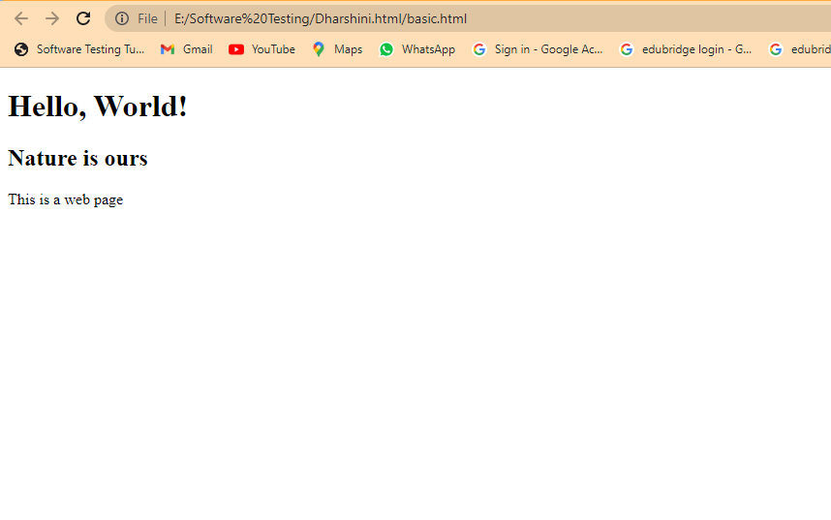

**HEADING TAGS**

<!DOCTYPE html>

<html>

<head>

<title>Heading Tags Example</title>

</head>

<body>

<p>All Heading Tags</p>

<h1>JAVA</h1>

<h2>PYTHON</h2>

<h3>WEB DESIGN</h3>

<h4>JAVASCRIPT</h4>

<h5>HTML</h5>

<h6>SQL</h6>

<p>This are all the 6 Heading Tags</p>

</body>

</html>

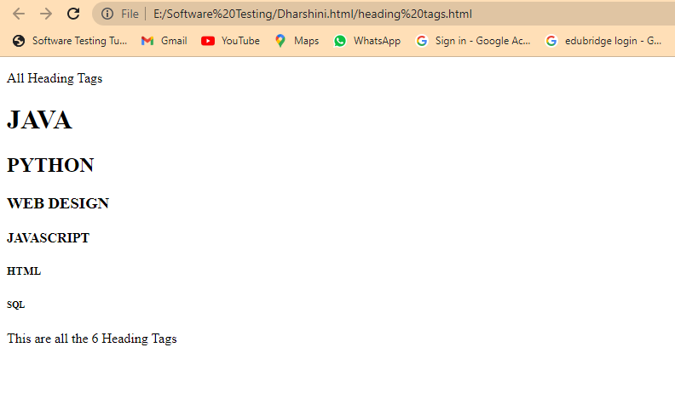

**ANCHOR TAG**

<!DOCTYPE html>

<html>

<head>

<title>Anchor Tag Example</title>

</head>

<body>

<h1>Anchor Tag Example</h1>

<p>This is a sample webpage with anchor links.</p>

<a href="https://www.youtube.com/">click here</a>

</body>

</html>

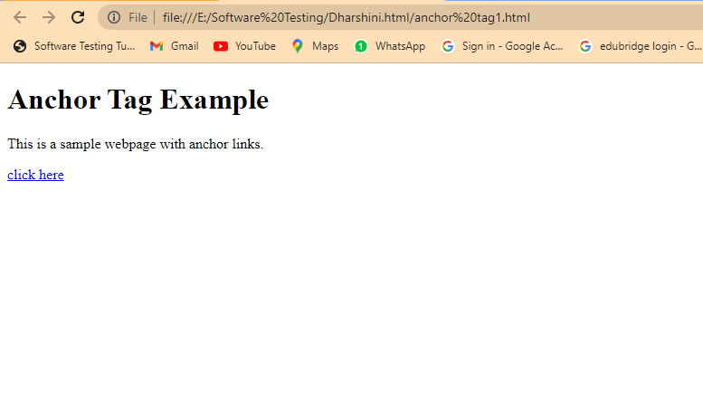

**BOOLEAN**

<!DOCTYPE html>

<html>

<body>

<h1>JavaScript Booleans</h1>

<p>Booleans and Boolean objects cannot be safely compared:</p>

<p id="demo"></p>

<script>

// x is a boolean

let x = false;

// y is an object

let y = new Boolean(false);

document.getElementById("demo").innerHTML = typeof x + "<br>" + typeof y;

</script>

</body>

</html>

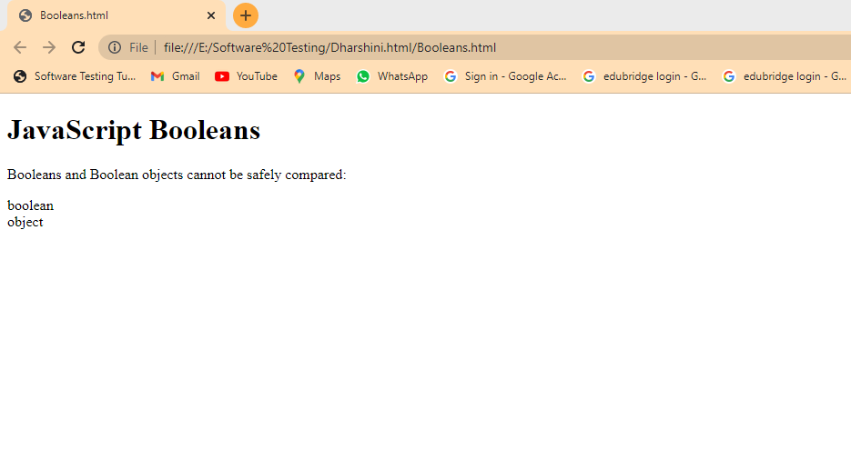

**GETFULLYEAR**

<!DOCTYPE html>

<html>

<body>

<h1>JavaScript Dates</h1>

<h2>The getFullYear() Method</h2>

<p>getFullYear() returns the year with four digits:</p>

<p id="demo"></p>

<script>

const d = new Date();

let year = d.getFullYear();

document.getElementById("demo").innerHTML = year;

</script>

</body>

</html>

